History Colloquium Series Fall 2017

Aleja Allen, “The Red Mini Skirt:
Nationalism in Irish America and Bernadette Devlin's 1969 Tour”

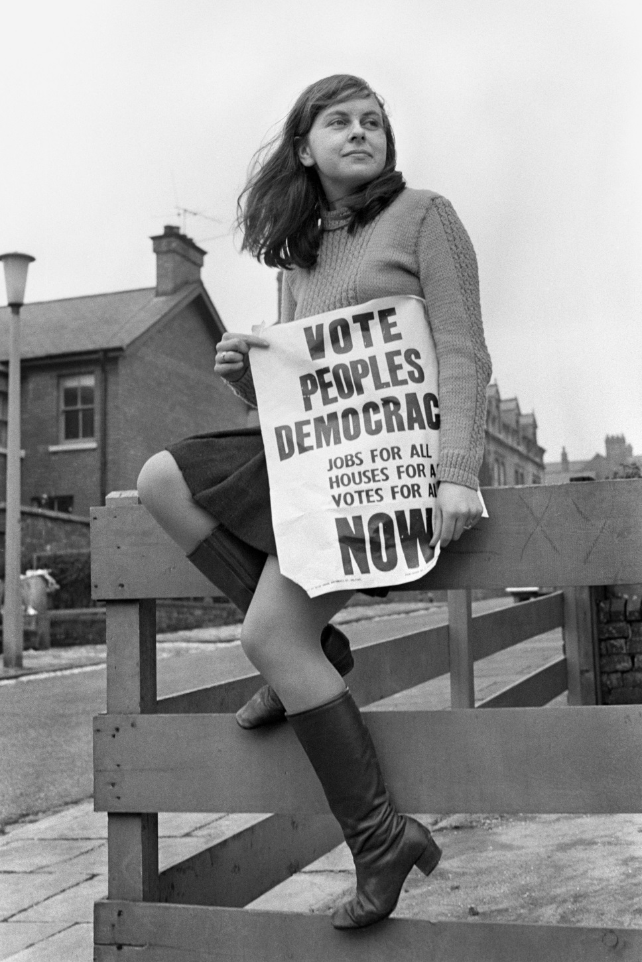
Friday 15 September
2-4PM
History Common Room (Mesa Vista 1104)

Paper available at history.unm.edu (click on News & Events)
Contact Dr. Caleb Richardson at cwr@unm.edu for more information

